Alright, for my code with mosh, I learned about styling badges. I created a badge and styled it in CSS. Here is my code:

CSS

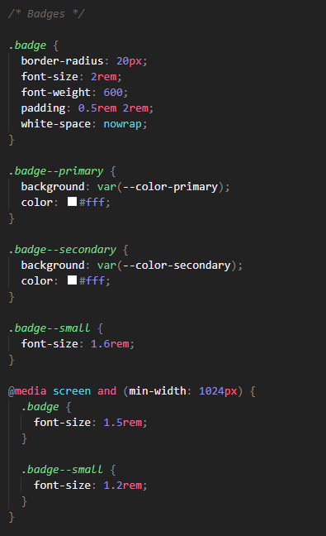

HTML

